**PERSONAL STYLIST SERVICE WEBSITE**

**Major Project Report**

**Submitted to**

**SRI PADMAVATI MAHILA VISVAVIDYALAYAM**

**In Practical fulfilment of the requirement for the**

**MASTER OF COMPUTER APPLICATIONS**

***IV SEMESTER***

**By**

**SHAIK SUMAYA (2022MCA16083)**

**Under the guidance of**

## Dr. P. BHARGAVI

**Assistant Professor**



Accredited by **NAAC with A+** Grade ISO 9001: 2015 Certified

**DEPARTMENT OF COMPUTER SCIENCE**

**SRI PADMAVATI MAHILA VISVAVIDYALAYAM (Women’s University)**

**Tirupati-517502(A.P), Andhra Pradesh**

**September,2024**

1

**DEPARTMENT OF COMPUTER SCIENCE**

**SRI PADMAVATI MAHILA VISVAVIDYALAYAM (Women’s University)**

**Tirupati-517502(A.P), Andhra Pradesh, India**

**Accredited with ‘A+’ Grade by NAAC**



**CERTIFICATE**

This is to certify that the project work entitled “**Personal stylist services”** is a Bonafede record of work carried by **SHAIK SUMAYA (2022MCA16083).**

In the Department of Computer Science, **SRI PADMAVATI MAHILA**

**VISVAVIDYALAYAM**, Tirupati in partial fulfilment of the requirements of IV

Semester of **MASTER OF COMPUTER APPLICATIONS**. The content of the

Project Report has not been submitted to any other University for the award of any degree.

*Guide**Head of the Department*

DECLARATION

We hereby declare that MCA **IV** Semester major project entitled **“Personal stylist services”** was done at the **Department of Computer Science**, **Sri Padmavati Mahila Visvavidyalayam**, Tirupati in the year 2023-2024 under the guidance of **Dr.P. Bhargavi** in partial fulfilment of requirements of MCA **IV** Semester.

We also declare that this project is my original contribution of the best of my knowledge and belief. We further declare that this work has not been submitted either in full or part for the award of any other degree of this or any other university.

Signature of the Student

**ACKNOWLEDGEMENT**

We are greatly indebted to our guide **Dr. P. Bhargavi** for

taking keen interest on my project work and providing valuable suggestions in all the possible areas of improvement.

We express our sincere thanks to the teaching staff of the Department of Computer Science for extending support and encouragement to me in all the stages of the project work.

We gratefully acknowledge and express my gratitude to the nonteaching staff of the Computer Science Department who supported us in preparing the project report.

Signature of the Student

INDEX

S.No. Content Page No.

**ABSTRACT 1**

1. **INTRODUCTION 2-3**
   1. Organization Profile
   2. University Profile
2. **PROBLEM DEFINITION 4-6** 
   1. Aim
   2. Problem Definition
   3. Objectives
3. **SYSTEM ANALYSIS 7-15**
   1. Software Requirement Specifications
   2. System Requirements
      1. Hardware Requirements
      2. Software Requirements
   3. Feasibility Study
      1. Operational Feasibility
      2. Technical Feasibility
      3. Economical Feasibility
   4. Modelling Approaches
      1. UML diagrams
         1. Use Case Diagrams
         2. Activity Diagrams
         3. Sequence Diagrams
      2. Data Flow Diagram
      3. Data Models

3.4.4.1.ER-Diagrams

3.4.4.2. Hipo Chart

1. **SYSTEM DESIGN 16-18** 
   1. Design principle
   2. Modularization
      1. Hierarchical chart

**4.3**. Database Design

1. **SYSTEM TESTING 19-22** 
   1. Testing Schemes

5.1.1. Unit Testing

* + 1. Integration Testing
    2. Functional Testing

5.1.4. Scalability Testing

* + 1. Acceptance Testing
  1. Test Cases

1. **IMPLEMENTATION 23-25**
2. **CONCLUSION 26**

**BILIBILOGRAPHY 27**

**APPENDICES 28-30** APPENDIX A: Screens

* Screen Shots
* Reports

**ABSTRACT**

The system facilitates seamless interactions between users and stylists, allowing users to browse available services, select preferred services, and schedule appointments based on their preferences. Stylists can efficiently manage appointments and provide personalized styling services to users. This project aims to develop a comprehensive personal stylist service system, catering to users seeking personalized styling solutions. The system provides users with access to a variety of styling services offered by professional stylists. The core functionalities include user registration and authentication, service browsing, appointment booking, and management of appointments.

Overall, this project aims to provide users with a convenient and reliable platform to access professional styling services, enhancing their overall experience in exploring and expressing their personal style.

**1.INTRODUCTION**

* 1. **ORGANIZATION PROFILE**

An initiative of **SmartBridge** in collaboration with **APSCHE** to Build a Job-Ready Talent Pool via Project-Based Learning.

Smartinternz initiative, in collaboration with APSCHE aims to build a jobready talent pool in the various demanding technologies.

This is a 4 months virtual internship, an experiential learning program designed to make the students employable. This program helps students build their profile aligned to a job role through hands-on project-based learning under the guidance of industry mentors. It helps students acquire technical and professional competencies while working on real-world challenges and creating innovative solutions. The program encourages students to think critically and creatively, and it is designed to provide industry-level training at the college level.

**1.2. UNIVERSITY PROFILE**

Sri Padmavati Mahila Visvavidyalayam (university for women) was founded in the year 1983 by N.T. Rama Rao, the Chief Minister of Andhra Pradesh, with the fervent desire to train women students as better builders of nation and to include skills of leadership in all aspects of life. The University was established under the Sri Padmavati Mahila Visvavidyalayam Act of 1983, which has come in to force on 14th of April 1983, it was started with ten faculties and 300 students and 20 staff members. In pursuance of objectives of university is awarded “A+ Grade” by NAAC.

The campus of Sri Padmavati Mahila Visvavidyalayam is spread out in lush green area of 138.43 acres. The university is situated as a distance of 3 kilometres from railway and bus stations of Tirupati. The campus has the necessary buildings to run its academic programs and administrative machinery. There are separate Buildings for humanities and science, university’s Administration, Central Library, University Auditorium, Sericulture complex and school of Pharmaceutical Sciences and also an independent building for Computer Science, Computer Centre and examination hall.

**2.PROBLEM DEFINITION**

**2.1. Aim**

Personal stylist services aim to help individuals develop their unique style and enhance their confidence by providing personalized fashion advice, wardrobe consultations, outfit selections, and shopping assistance tailored to their preferences, body type, and lifestyle. The goal is to help clients look and feel their best in any situation, whether it's for everyday wear, special occasions, or professional settings.

* 1. **Problem Definition**

In personal stylist services, problem definition involves understanding the client's specific fashion challenges, preferences, and goals. This includes identifying areas where the client may feel dissatisfied with their current wardrobe, struggles with finding appropriate clothing for their body type or lifestyle, or lacks confidence in their personal style. By clearly defining these issues, the stylist can tailor their services to address the client's unique needs effectively. This may involve conducting consultations, assessing the client's current wardrobe, and discussing their fashion preferences and aspirations.

1. Lack of personalized recommendations: Users may not receive tailored suggestions that match their individual preferences and style.

2. Limited inventory: A restricted range of clothing options may limit users' choices and fail to cater to diverse tastes and body types.

3. Poor user experience: Complicated navigation, slow loading times, or unclear instructions can frustrate users and deter them from using the website.

4. Inaccurate sizing information: Incorrect sizing charts or inconsistent sizing across brands can lead to dissatisfaction and returns.

5. Insufficient communication channels: Users may struggle to get in touch with stylists for advice or assistance, leading to a disconnect in the customer-stylist relationship.

6. High costs: Expensive subscription fees or consultation rates may deter potential clients from utilizing the service.

7.Addressing these issues through improved technology, streamlined processes, and enhanced communication can help personal stylist services websites provide a better user experience and attract more customers.

**2.3. OBJECTIVES:**

The objectives of personal stylist services typically include:

1. Enhancing Personal Style: Help clients discover and refine their personal style by providing expert advice, guidance, and recommendations tailored to their individual preferences, body type, and lifestyle.

2. Boosting Confidence: Empower clients to feel confident and comfortable in their appearance by curating outfits that align with their personality, preferences, and aspirations.

3. Saving Time: Streamline the shopping process for clients by eliminating the need to search through countless options themselves. Personal stylists can save clients time by selecting clothing and accessories that meet their needs and preferences.

4. Providing Fashion Education: Educate clients about current fashion trends, styling techniques, and wardrobe essentials to help them make informed decisions about their clothing choices and develop a cohesive wardrobe.

5. Maximizing Wardrobe Versatility: Assist clients in building versatile wardrobes that can be mixed and matched to create various outfits for different occasions, maximizing the value of their clothing investments.

6. Offering Convenience: Provide a convenient and accessible platform for clients to access personalized styling services, whether through in-person consultations, virtual styling sessions, or online platforms.

7. Building Long-Term Relationships: Foster long-term relationships with clients by delivering exceptional service, building trust, and adapting to their evolving style preferences and lifestyle changes over time.

By focusing on these objectives, personal stylist services aim to deliver value to clients and help them look and feel their best in every aspect of their lives.

**3.SYSTEM ANALYSIS**

**3.1. System Requirement Specifications**

The Model that is basically being followed is the “Software Development Life Cycle Model”, which state the feasibility study is done once the part is over the requirement analysis and project planning is beings. If system exists once the modification and addition of new module is needing analysis of present system, can we use as basic model.

The design starts after the requirement analysis complete and the coding begins after the design is completed once the programming completed the testing is done. In this model the sequence of activity performed in a software development project are:

* Planning
* Requirement
* Design
* Software development
* Testing
* Deployment
* Operation and maintenance

**3.2. System Requirements:**

**3.2.1. Hardware Requirements**

|  |  |  |
| --- | --- | --- |
| ➢ System | : | Intel Core i5 |
| ➢ Hard Disk | : | 1TB. |
| ➢ Monitor | : | 15’’ LED |
| ➢ Input Devices | : | Keyboard,Mouse |
| ➢ RAM | : | 8GB. |

**3.2.2. Software Requirements**

|  |  |
| --- | --- |
| ➢ Operating System : | Windows 10. |
| ➢ Coding Languages: | HTML, JavaScript. |
| ➢ Tool : | WordPress,XAMPP. |
| ➢ Database : | MySQL |

**3.3. Feasibility Study:**

The feasibility of the project is analysed in this phase and business proposal is put forth with a very general plan for the project and some cost estimates. During system analysis the feasibility study of the proposed system is to be carried out. This is to ensure that the proposed system is not a burden to the company. For feasibility analysis, some understanding of the major requirements for the system is essential.

**Three key considerations involved in the feasibility analysis are,**

* OPERATIONAL FEASABILITY
* TECHNICAL FEASABILITY
* ECONOMICAL FEASABILITY

**3.3.1. OPERATIONAL FEASABILITY**

The aspect of study is to check the level of acceptance of the system by the user. This includes the process of training the user to use the system efficiently. The user must not feel threatened by the system, instead must accept it as a necessity. The level of acceptance by the users solely depends on the methods that are employed to educate the user about the system and to make him familiar with it. His level of confidence must be raised so that he is also able to make some constructive criticism, which is welcomed, as he is the final user of the system.

**3.3.2. TECHNICAL FEASABILITY**

This study is carried out to check the technical feasibility, that is, the technical requirements of the system. Any system developed must not have a high demand on the available technical resources. This will lead to high demands on the available technical resources. This will lead to high demands being placed on the client. The developed system must have a modest requirement, as only minimal or null changes are required for implementing this system.

**3.3.3. ECONOMICAL FEASABILITY**

This study is carried out to check the economic impact that the system will have on the organization. The amount of fund that the company can pour into the research and development of the system is limited. The expenditures must be justified. Thus, the developed system as well within the budget and this was achieved because most of the technologies used are freely available. Only the customized products had to be purchased.

**3.4. MODELING APPROACHES:**

**3.4.1. UML DIAGRAMS**

UML stands for Unified Modelling Language. UML is a standardized general-purpose modelling language in the field of object-oriented software engineering. The standard is managed, and was created by, the Object Management Group.

The goal is for UML to become a common language for creating models of object-oriented computer software. In its current form UML is comprised of two major components: a Meta-model and a notation. In the future, some form of method or process may also be added to; or associated with, UML.

The Unified Modelling Language is a standard language for specifying, Visualization, Constructing and documenting the artifacts of software system, as well as for business modelling and other non-software systems.

The UML represents a collection of best engineering practices that have proven successful in the modelling of large and complex systems.

The UML is a very important part of developing objects-oriented software and the software development process. The UML uses mostly graphical notations to express the design of software projects.

**3.4.1.1 USECASE DIAGRAM**

A use case diagram in the Unified Modelling Language (UML) is a type of behavioural diagram defined by and created from a Use-case analysis. Its purpose is to present a graphical overview of the functionality provided by a system in terms of actors, their goals (represented as use cases), and any dependencies between those use cases. The main purpose of a use case diagram is to show what system functions are performed for which actor. Roles of the actors in the system can be depicted.

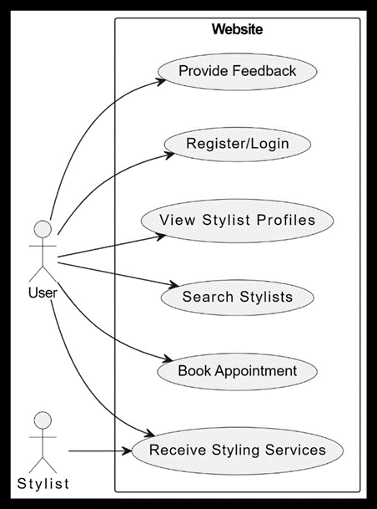

**3.4.1.2. Active diagrams:**

This activity diagram outlines the steps a user takes when using a personal stylist services website, including logging in or registering, browsing stylist profiles, searching for stylists, and booking appointments.

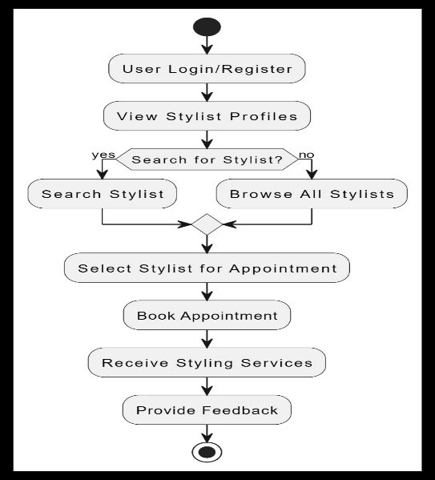

**3.4.1.3. SEQUENCE DIAGRAM**

A sequence diagram is a type of interaction diagram in Unified modelling Language (UML) used to visualize the interactions between objects or components within a system in a chronological order. It shows the flow of messages and calls between different parts of a system, typically overall.

Sequence diagrams are particularly useful for understanding how different parts of a system interact with each other and for designing and documenting the behaviour of systems, especially in the context of object-oriented software development. They provide a clear visualization of the dynamic behaviour of a system and help in identifying potential issues or improvements in system design.

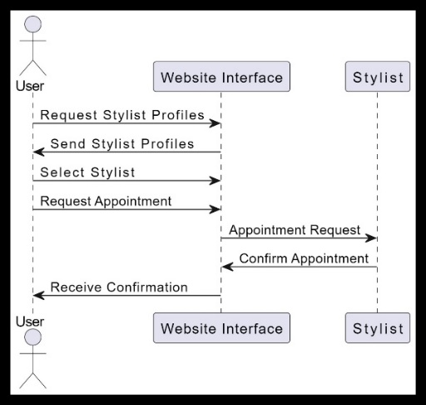

**3.4.2. DATA FLOW DIAGRAM**

A Data Flow Diagram (DFD) is a traditional visual representation of the information flows within a system. A neat and clear DFD can depict the right amount of the system requirement graphically. It can be manual, automated, or a combination of both.

It shows how data enters and leaves the system, what changes the information, and where data is stored.

The objective of a DFD is to show the scope and boundaries of a system as a whole. It may be used as a communication tool between a system analyst and any person who plays a part in the order that acts as a starting point for redesigning a system. The DFD is also called as a data flowgraphorbubblechar

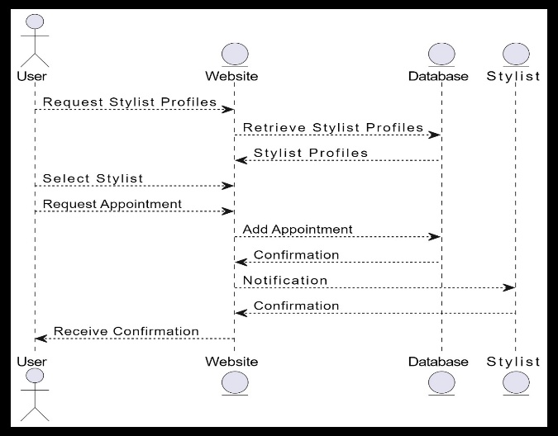

**3.4.3. Data Models**

**3.4.4.1. ER-Diagrams**

An entity-relationship (ER) diagram is a specialized graphic that illustrates the interrelationships between entities in a database. ER diagrams often use symbols to represent three different types of information. Boxes are commonly used to represent entities. Diamonds are normally used to represent relationships and ovals are used to represent attributes. An entity-relationship model (FRM) in software engineering is an abstract and conceptual representation of data. Entity-relationship modelling is a relational schema database modelling method, used to produce a type of conceptual schema or semantic data model of a system, often a relational database, and its requirements in a top-downfashion.

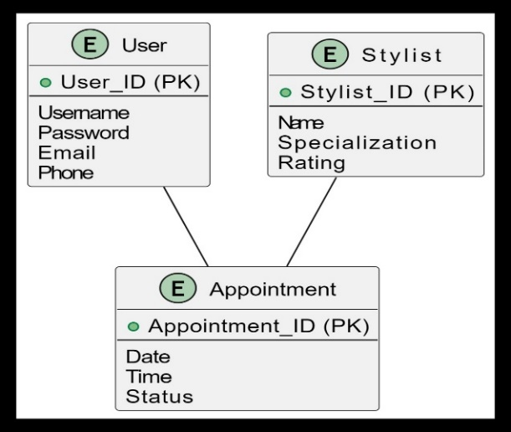

Fig:3.4.3.1: Entity Relationship Diagram

**3.4.4.2. Hipo Chart**

HIPO chart, which stands for Hierarchy plus Input-Process-Output, is a type of structured diagram used in systems analysis and software engineering to represent the structure and functionality of a system or process. It combines elements of hierarchy charts and IPO (Input-Process-Output) charts into a single diagram.

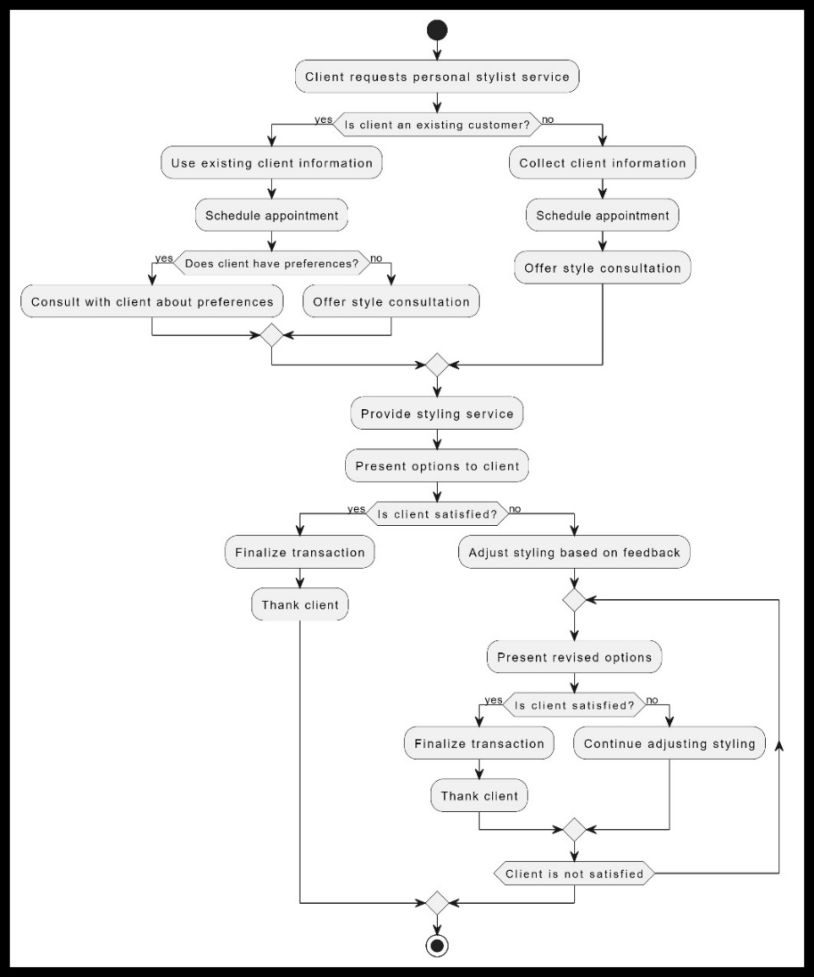

# 4.SYSTEM DESIGN

The design phase of a software system to build an answer for the issue as characterized in the requirement elicitation process. Design stage sets up a general architecture by dividing the software into parts, the connections and condition between such segments is then settled.

**4.1 DESIGN PRINCIPLE**

Software Design is also a process to plan or convert the software requirements into a step that are needed to be carried out to develop a software system There are several principles that are used to organize and arrange. the structural components of Software design Software Designs in which these principles are applied affect the content and the working process of the software from the beginning.

* **Scalability:** A system is scalable if it is designed so that it can handle additional load and will still operate efficiently.
* **Reliability:** A system is reliable if it can perform the function as expected, it can tolerate user mistakes, is good enough for the required use case, and it also prevents unauthorized access or abuse
* **Availability**: A system is available if it is able to perform its functionality (uptime/total time). Note reliability and availability are related but not the same. Reliability implies availability but availability does not imply reliability.
* **Efficiency:** A system is efficient if it is able to perform its functionality quickly Latency, response time and bandwidth are all relevant metrics to measuring system efficiency.
* **Maintainability:** A system is maintainable if it easy to make operate smoothly, simple for new engineers to understand, and easy to modify for unanticipated use cases.

Basic design principles that enable the software engineer to navigate the design process are.

* The design should be tracked to the analysis model.
* The design should not reinvent the wheel.
* The design should minimize the intellectual distance between the software and the problem as exits in the real world.
* The design should exhibit uniformity and integrity.
* The design should be structure to accommodate changes.
* The design is not coding the coding is not a design.

**8 Golden Rules for system design**

* Strive for consistency
* Enable Short-cuts for frequent users
* Informative feedback
* Design dialogues to yield closer
* Offer simple error handling
* Permit easy reversal of actions
* Support internal locus of control
* Reduce short term memory load on user

**4.2. Modularization**

Modularization in personal stylist services involves breaking down the service into distinct modules or components that clients can choose from based on their needs. For example, clients might opt for modules such as wardrobe analysis, personal shopping, or virtual styling sessions, allowing for customization and flexibility in service delivery. This approach can cater to a wider range of clients and adapt to their preferences and budgets.

### 4.2.1. Hierarchical Chart

### 

**4.3. Database Design**

A database for personal stylist services serves as the backbone of operations, facilitating efficient management of clients, stylists, appointments, and inventory. Here's a deeper dive into the design considerations.

Designing a database for personal stylist services involves creating tables to store information about clients, stylists, appointments, and inventory.

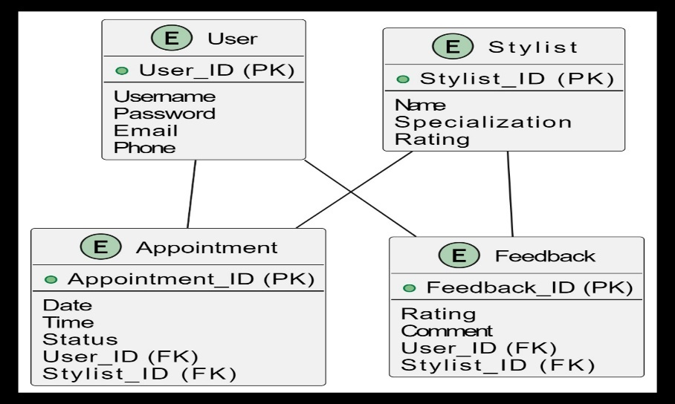

Figure 4.3: Personal stylist service

### 5.SYSTEM TESTING

### System Testing includes testing of a fully integrated software system. Generally, a computer system is made with the integration of software (any software is only a single element of a computer system). The software is developed in units and then interfaced with other software and hardware to create a complete computer system.

**5.1. Testing schemes**

**5.1.1. Unit testing**

Unit Testing is a method of testing individual units or components of a software application. It is typically done by developers and is used to ensure that the individual units of the software are working as intended. Unit tests are usually automated and are designed to test specific parts of the code, such as a particular function or method. Unit testing is done atthe lowest level of the Software development process where individual units of code are tested in isolation.

**5.1.2. Integration testing**

Integration testing is a method of testing how different units or components of a software application interact with each other. It is used to identify and resolve any issues that may arise when different units of the software are combined. Integration testing is typically done after unit testing and before functional testing and is used to verify that the different units of the software work together as intended.

**5.1.3. Functional Testing:**

Software application interact with each other. It is used to identify and resolve any issues that may arise when different units of the software are combined. Integration testing is typically done after unit testing and before functional testing and is used to verify that the different units of the software work together as intended

**5.1.4. Scalability testing**

Assess the system's ability to handle increased workload or data volume over time. Test scalability by gradually increasing the load or adding resources. System testing is a critical phase in the software development life cycle aimed at ensuring that the entire system, including its components or modules, behaves as expected and meets the specified requirements. It involves testing the integrated system as a whole to validate its functionality, performance, reliability, and other quality attributes.

**5.1.5. Acceptance Testing:**

User acceptance testing is used to determine whether the product is working for the user correctly. Specific requirements which are quite often used by the customers are primarily picked for testing purposes. This is also termed as *End-User* Testing.

## 5.2 Test Cases

## Creating test cases for personal stylist services involves evaluating various aspects such as user experience, functionality, and performance. Here are some test cases to consider:

1. User Registration:

- Test registering a new user account.

- Test registering with valid and invalid inputs (e.g., email format, password requirements).

- Verify email verification process.

2. User Profile Management:

- Test updating user profile information (name, contact details, etc.).

- Test changing password.

- Verify user profile picture upload functionality.

3. Styling Preferences:

- Test selecting styling preferences (e.g., preferred clothing style, colors, sizes).

- Verify that preferences are saved correctly for each user.

4. Appointment Booking:

- Test booking an appointment with a stylist.

- Test selecting date and time.

- Verify confirmation email or notification is sent.

5. Stylist Matching:

- Test matching users with suitable stylists based on preferences.

- Verify that the algorithm correctly matches users with stylists based on their requirements.

6. Styling Session:

- Test starting a styling session.

- Verify the communication tools (e.g., chat, video call) work properly.

- Test sharing images or links for styling suggestions.

7. Feedback and Rating:

- Test providing feedback after the styling session.

- Verify that users can rate their stylist and leave comments.

- Test viewing and responding to feedback for stylists.

8. Payment and Invoicing:

- Test making a payment for the styling service.

- Verify the accuracy of the invoice generated.

- Test refund process (if applicable).

9. Accessibility and Compatibility:

- Test the platform on different devices (desktop, mobile, tablet).

- Verify compatibility with different browsers (Chrome, Firefox, Safari, Edge).

- Test accessibility features for users with disabilities (screen readers, keyboard navigation).

10. Performance Testing:

- Test the system under heavy load (multiple users booking appointments simultaneously).

- Verify response times for various actions (booking, profile update, etc.).

- Test error handling under stressful conditions.

These test cases cover a range of functionalities and scenarios to ensure the personal stylist service operates smoothly and meets user expectations.

# 6.IMPLEMENTATION

Implementing a personal stylist service involves several components and technologies. Here's a high-level overview of how you might approach it:

1. Frontend Development:

- Use HTML, CSS, and JavaScript to create the user interface for the service's website or application.

- Consider using a frontend framework like React.js or Angular to manage state and components efficiently.

- Implement responsive design to ensure the service works well on various devices.

2. Backend Development:

- Choose a backend technology stack based on your team's expertise and project requirements. Options include Node.js with Express.js, Python with Django or Flask, Ruby on Rails, etc.

- Develop RESTful APIs to handle user authentication, profile management, appointment booking, stylist matching, feedback/rating, and payment processing.

- Implement database functionality using SQL (e.g., PostgreSQL, MySQL) or NoSQL (e.g., WordPress) databases to store user data, stylist profiles, appointments, etc.

- Integrate third-party APIs for services like payment processing (e.g., Stripe, PayPal), email notification (e.g., SendGrid, Mail gun), and image/video sharing (e.g., Cloudinary).

3. Stylist Matching Algorithm:

- Design and implement an algorithm to match users with suitable stylists based on their preferences, location, availability, and expertise.

- Consider using machine learning techniques to improve matching accuracy over time based on user feedback and historical data.

4. Real-time Communication:

- Integrate real-time communication features such as chat and video calling using WebSockets or a third-party service like Twilio or Socket.io.

- Ensure secure and reliable communication channels between users and stylists.

5. Payment Processing:

- Implement secure payment processing functionality using a trusted payment gateway API (e.g., Stripe, PayPal).

- Handle various payment methods (credit/debit cards, digital wallets, etc.) and currencies based on user preferences and location.

6. User Experience (UX) Design:

- Focus on creating an intuitive and visually appealing user experience to enhance user engagement and satisfaction.

- Conduct user research and usability testing to gather feedback and iterate on the design.

7. Quality Assurance (QA) and Testing:

- Develop comprehensive test cases to ensure the reliability, performance, and security of the service.

- Conduct unit tests, integration tests, and end-to-end tests to identify and fix bugs and issues early in the development process.

8. Deployment and Maintenance:

- Deploy the service to a reliable hosting platform (e.g., AWS, Google Cloud, Heroku) and configure scaling options to handle increased traffic.

- Implement monitoring and logging tools to track system performance, detect errors, and troubleshoot issues promptly.

- Regularly update and maintain the service to incorporate new features, security patches, and improvements based on user feedback and market trends.

# By following these steps and leveraging appropriate technologies, you can create a robust and user-friendly personal stylist service that meets the needs of both users and stylists.

# 7.CONCLUSION

# In conclusion, the creation of a personal stylist services website represents an exciting opportunity to revolutionize the way individuals engage with fashion expertise. Through intuitive design, seamless functionality, and a commitment to user satisfaction, this platform seeks to empower users to explore their personal style with confidence. By leveraging cutting-edge technologies, implementing robust security measures, and prioritizing user feedback, the website aims to cultivate a vibrant community of users and stylists united by a shared passion for fashion. With a dedication to continuous improvement and innovation, this website aspires to redefine the fashion industry landscape, offering personalized style solutions that resonate with users on a deeply individual level.

In summary, a successful personal stylist services website combines innovative technology, thoughtful design, and user-centric features to deliver a tailored and engaging fashion experience. By prioritizing user needs, security, and ongoing optimization, such a website can establish itself as a trusted platform for individuals seeking personalized style advice and inspiration.

**BILIBILOGRAPHY**

For a project like an Event Management and Ticketing Platform, your bibliography could include various resources such as:

Online Tutorials and Documentation:

W3Schools. (https:/[/www.w3schools.com/)](http://www.w3schools.com/))

Mozilla Developer Network (MDN).(https://developer.mozilla.org/) Google Chrome for project view. (https:/[/www.google.com/)](http://www.google.com/))

Books:

"Learning Web Design" by Jennifer Robbins.

"Eloquent JavaScript" by Marijn Hoverbike.

Research Papers (if applicable):

Research papers or articles on topics related to event management, ticketing systems, and web development.

Official Documentation for Tools:

Documentation for tools or platforms you've used, such as database systems, web servers, or deployment tools.

**APPENDICES**

Appendices refer to supplementary materials or additional documents that are attached to the main document to provide further information, details or support. They are typically used to include information that might be too extensive or detailed to be included in the main body other document but is relevant to the overall content.

In the context of a document related to an event management and ticket platform, appendices can include various supporting materials such as user guides, technical specifications, policies, guidelines, and other documents that provide additional context, details or reference information.

**APPENDIX A: Screens**

**Screen Shots:**

